Balanced Score Card:
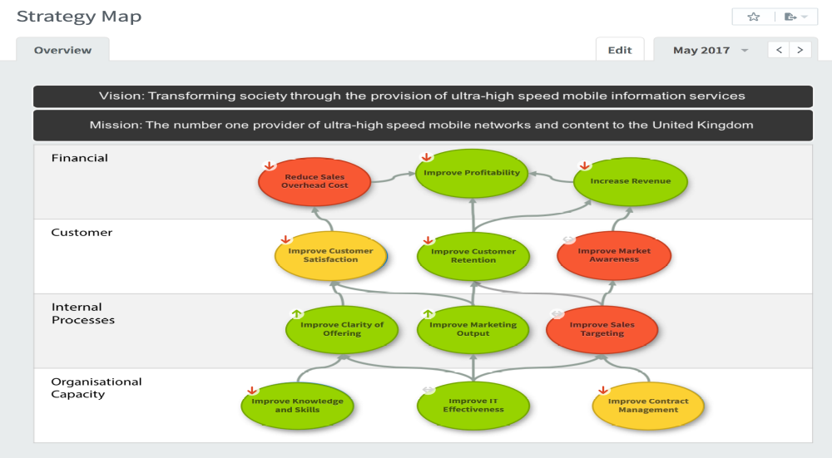
The Balanced Scorecard (BSC) is a framework used to implement and manage strategy by connecting a vision and mission to strategic priorities, objectives, measures, and initiatives. It offers a comprehensive view of an organization's performance by integrating financial measures with other key performance indicators related to customers, internal business processes, and organizational capacity.
Originally introduced by Dr. Robert Kaplan and Dr. David Norton in 1992, the Balanced Scorecard gained widespread success after its formal publication as a book in 1996. It is more than just a scorecard; it is a methodology that identifies a small number of financial and non-financial objectives aligned with strategic priorities. These objectives are then measured, targeted, and supported by strategic initiatives.
The Balanced Scorecard focuses on four perspectives, namely Financial, Customer, Internal Processes, and Organizational Capacity, to achieve a balance in evaluating organizational performance. These perspectives provide a structured framework for describing a business strategy and help in setting objectives and measures that inform progress and influence activities to achieve strategic goals.
The four perspectives are interconnected, with changes in Organizational Capacity driving improvements in Business Processes, which in turn affect Customers and lead to enhanced Financial results. While additional perspectives like Health and Safety could be included, the four perspectives have proven effective over time and maintain a causal relationship that ensures a balanced approach.
Strategic Objectives, described as the "DNA" of the Balanced Scorecard system, play a crucial role in turning a passive strategy into an active one. These objectives apply to all levels of an organization and provide clear guidance on what is important. It's essential to distinguish strategic objectives from activities or projects and ensure that they are measurable and contribute to continuous improvement aligned with the organization's vision and mission.

Key Performance Indicators (KPIs) are quantifiable measures that organizations use to evaluate their success in achieving key business objectives. They provide essential information that helps determine whether an organization is performing well or not. Here's why KPIs are important and how they are useful:
- Measuring Performance: KPIs serve as benchmarks to gauge performance against strategic objectives. They provide a clear indication of whether an organization is moving in the right direction or needs to adjust its strategies.
- Strategic Alignment: KPIs are directly linked to an organization's strategic objectives. They ensure that efforts and resources are focused on activities that contribute to the overall goals and mission of the organization.
- Driving Improvement: By monitoring KPIs, organizations can identify areas of weakness or inefficiency and take corrective actions to improve performance. KPIs highlight areas that require attention, enabling proactive decision-making.
- Accountability: KPIs create accountability at all levels of an organization. When individuals or teams are responsible for specific KPIs, they are motivated to achieve targets and contribute to overall organizational success.
- Communication: KPIs provide a common language for discussing performance across different departments and levels of an organization. They facilitate communication and alignment of goals and priorities.
- Focus and Prioritization: By focusing on a select number of KPIs, organizations can avoid information overload and prioritize efforts on areas that have the greatest impact on success. This prevents spreading resources too thinly and ensures efficient allocation of resources.
- Continuous Improvement: KPIs should include both leading and lagging indicators. Leading indicators help identify potential issues before they escalate, allowing organizations to take proactive measures to prevent problems and drive continuous improvement.
Overall, KPIs are essential tools for organizations to track progress, align efforts with strategic objectives, drive performance improvement, and ultimately achieve long-term success.

Steps of Balanced score card
Certainly, here's the Balanced Scorecard (BSC) process for an International Affairs Office in a higher education institute presented in table form:
Step | Action | Example for International Affairs Office
1. | Clarify Vision and Strategy | Define the long-term vision and strategic goals.  Vision: "Enhance the global standing and international collaborations of the institute."
2. | Identify Perspectives | Break down the strategy into the BSC perspectives: Financial, Customer, Internal Processes, and Learning & Growth.
3. | Develop Objectives | Define specific objectives for each perspective. . Financial: Improve cost-efficiency of international programs. . Customer: Increase satisfaction among international students and partners. . Internal Processes: Streamline visa and admission processes for international students. . Learning & Growth: Enhance staff expertise in international education trends and regulations.
4. | Set Performance Measures | Choose KPIs for each objective. . Financial: Ratio of program costs to the number of international students enrolled. . Customer: Satisfaction levels of international students and partners. . Internal Processes: Average processing time for visa and admissions. . Learning & Growth: Number of staff training sessions on international regulations held per year.
5. | Set Targets | Establish targets for each KPI. . Financial: Reduce program costs by 10%, increase student enrollment by 5%. . Customer: Achieve a 90% satisfaction rate. . Internal Processes: Reduce processing time by 15%. . Learning & Growth: Conduct at least four training sessions annually.
6. | Define Initiatives | Outline projects or actions to achieve targets. Financial: Launch virtual exchange programs. . Customer: Implement a mentorship program. . Internal Processes: Develop an online portal for processing. . Learning & Growth: Establish partnerships for staff development.
7. | Implement and Monitor | Roll out initiatives and track progress. . Implement the mentorship program and monitor its impact on student satisfaction.
8. | Review and Adapt | Periodically review the BSC and make adjustments. . Conduct annual reviews to assess the effectiveness of current initiatives and adjust strategies as needed.
By aligning the Balanced Scorecard (BSC) creation process with the Plan-Do-Check-Act (PDCA) cycle, the steps are categorized under each phase of PDCA as follows:
Plan
- Clarify Vision and Strategy: Define the long-term vision and strategic goals.
- Identify Perspectives: Break down the strategy into the BSC perspectives: Financial, Customer, Internal Processes, and Learning & Growth.
- Develop Objectives: Define specific objectives for each perspective.
- Set Performance Measures: Choose Key Performance Indicators (KPIs) for each objective.
Do
- Set Targets: Establish clear targets for each KPI.
- Define Initiatives: Outline specific projects or actions to achieve each target.
Check
- Implement and Monitor: Roll out the initiatives and regularly track progress against the targets using the defined KPIs.
Act
- Review and Adapt: Conduct periodic reviews of the entire BSC to ensure alignment with the strategic vision and make necessary adjustments based on performance and changing circumstances.
By structuring the BSC creation process within the PDCA cycle, the International Affairs Office can adopt a systematic approach to continuous improvement, ensuring that the strategy remains dynamic and responsive to new challenges and opportunities.

KPI VS BCS
Aspect | KPI | BSC
Definition | KPIs are like report cards for specific goals or tasks. They tell you how well something is doing. | Balanced Scorecard is a system that helps a company make sure it's doing well in different areas. It's like looking at the bigger picture.
Focus | KPIs focus on one thing at a time, like how much money you're making or how happy your customers are. | Balanced Scorecard looks at everything important to a company, like money, customers, how things work inside, and how people learn and grow.
Usage | KPIs help you see if you're doing a good job and where you can do better. | Balanced Scorecard helps companies set goals and see if they're moving in the right direction.
Implementation | You can use KPIs for different jobs in a company, like sales or customer service. | Balanced Scorecard is usually used by the whole company to make big plans and decisions.
Perspective | KPIs look at just one part of the company, like how much money is coming in. | Balanced Scorecard looks at many parts together to see the whole picture.
Nature | KPIs mostly use numbers to show how well something is doing. | Balanced Scorecard uses numbers and also other things, like how people feel about the company.
Strategic Alignment | KPIs might not always match up with what the company wants to do. | Balanced Scorecard always matches up with the big plans and goals of the company.
Time Orientation | KPIs mostly look at what's happening now or what happened before. | Balanced Scorecard helps the company plan for the future.
Complexity | KPIs are usually easy to understand and use. | Balanced Scorecard can be a little complicated because it looks at many different things together.

